**Reg. No: 21BCE1297 Name: Vidhi Shah Date: 24/03/22**

**PPS9**

**Q1**

**Aim:**

Given an array of size N, write a C program using pointer arithmetic to find the sum of the digits of all array elements which contains even number of 1’s in their equivalent binary representation. If there is no such element with even number of 1’s, print -1.

**Procedure:**

**Input:**

A number, ‘n’

‘n’ array elements

**Output:**

Sum of digits of all elements from array that satisfies the condition else -1

**Algorithm:**

Step 1: Declare ‘binary’, ‘eveodd’ and ‘digitsum’ function with return type ‘int’ and argument ‘int n’

**Main Function**

Step 1: Initialise integer variables ‘n’ and ‘i’ and read ‘n’.

Step 2: Initialise and read an integer array of size n, ‘arr’.

Step 3: Initialise an integer pointer variable, ‘ptr’, and assign ‘arr’ to it.

Step 4: Initialise ‘sum’ to 0, declare ‘r’

Step 5: For each element of the array

Step A: Pass element in ‘binary function’ using pointer reference

Step B: Pass the binary number obtained in ‘eveodd function’ and store the

return value in ‘r’

Step C: If r is equal to 1

Then pass the element in ‘digitsum function’ using pointer reference

and add the return value to ‘sum’

Step D: Increment ‘ptr’ by 1

Step 6: If ‘sum’ is equal to 0

Print -1

Else

Print ‘sum’

Step 7: Return 0

**Binary Function**

Step 1: Initialise ‘i' to 0, ‘b’ to 1 and declare ‘r’

Step 2: While n > 0

Step A: r = n%2

Step B: b += r*i

Step C: i *= 10

Step D: n /= 2

Step 3: Return b

**Eveodd Function**

Step 1: Initialise ‘c' to 0 and declare ‘r’

Step 2: While n > 0

Step A: r = n%10

Step B: If r is equal to 1

Increment c by 1

Step C: n /= 10

Step 3: If c is even

Return 0

Else

Return 1

**Digitsum Function**

Step 1: Initialise ‘s’ to 0

Step 2: While n > 0

s += n % 10

n /= 10

Step 3: Return s

**Code:**

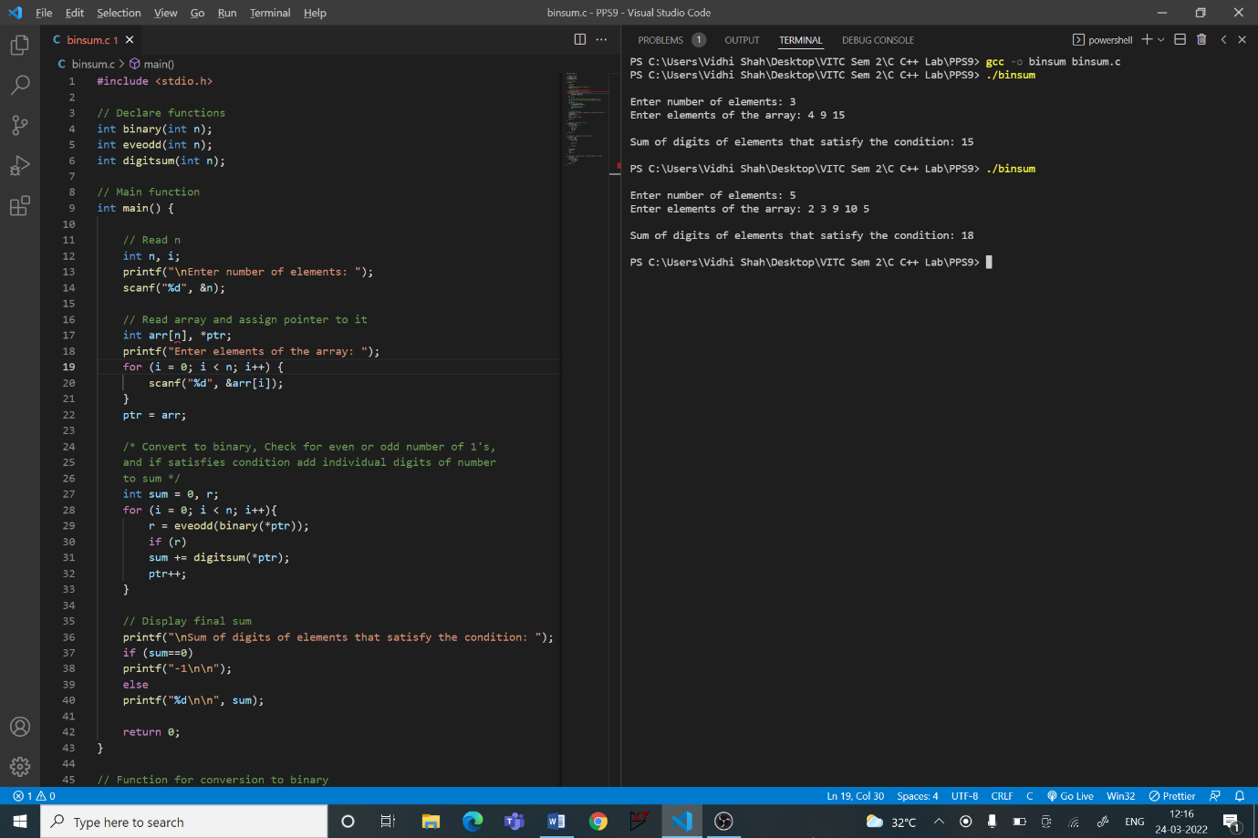

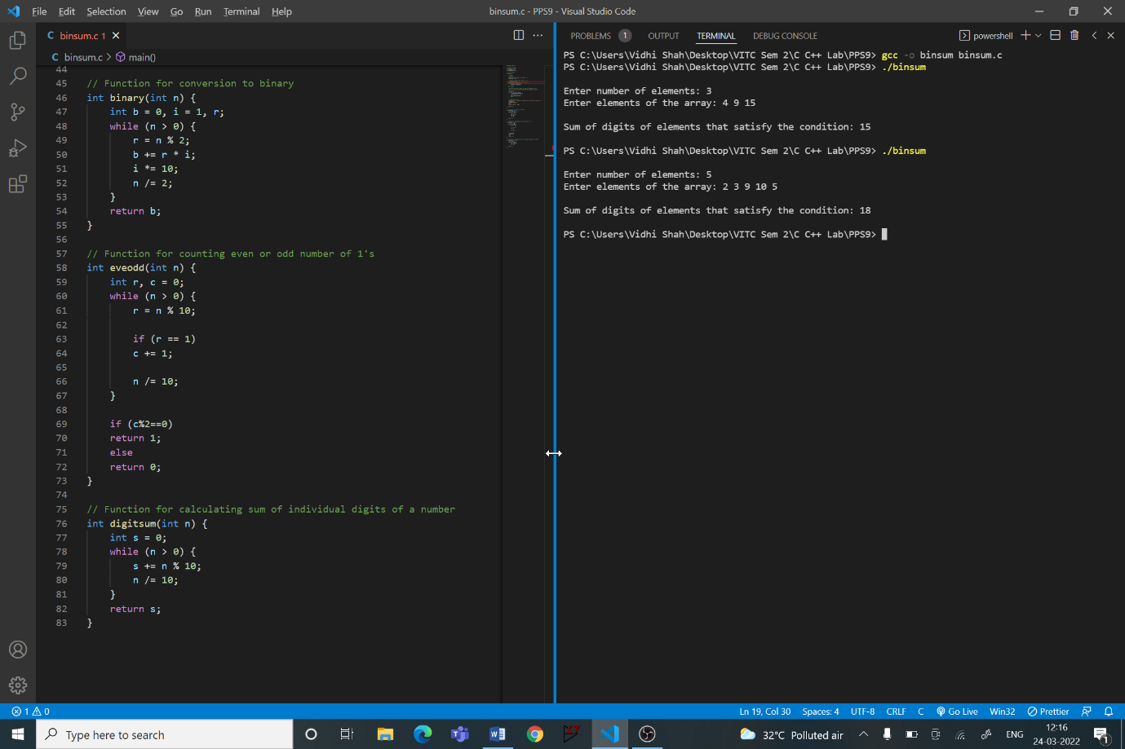

#include <stdio.h>

// Declare functions

int binary(int n);

int eveodd(int n);

int digitsum(int n);

// Main function

int main() {

    // Read n

    int n, i;

    printf("\nEnter number of elements: ");

    scanf("%d", &n);

    // Read array and assign pointer to it

    int arr[n], *ptr;

    printf("Enter elements of the array: ");

    for (i = 0; i < n; i++) {

        scanf("%d", &arr[i]);

    }

    ptr = arr;

    /* Convert to binary, Check for even or odd number of 1's,

    and if satisfies condition add individual digits of number

    to sum */

    int sum = 0, r;

    for (i = 0; i < n; i++){

        r = eveodd(binary(*ptr));

        if (r)

        sum += digitsum(*ptr);

        ptr++;

    }

    // Display final sum

    printf("\nSum of digits of elements that satisfy the condition: ");

    if (sum==0)

    printf("-1\n\n");

    else

    printf("%d\n\n", sum);

    return 0;

}

// Function for conversion to binary

int binary(int n) {

    int b = 0, i = 1, r;

    while (n > 0) {

        r = n % 2;

        b += r * i;

        i *= 10;

        n /= 2;

    }

    return b;

}

// Function for counting even or odd number of 1's

int eveodd(int n) {

    int r, c = 0;

    while (n > 0) {

        r = n % 10;

        if (r == 1)

        c += 1;

        n /= 10;

    }

    if (c%2==0)

    return 1;

    else

    return 0;

}

// Function for calculating sum of individual digits of a number

int digitsum(int n) {

    int s = 0;

    while (n > 0) {

        s += n % 10;

        n /= 10;

    }

    return s;

}